4233303 - Division - JE Report Filter
Division enhancement: Division Filter for Journal Entry Report (Epic 4233303)1. Customer Problemneed division-specific JE reports without manual filtering.

2. Customer Researchadd division filter; include JEs with distributions to accounts in selected division.

This capability was requested as feedback from an enterprise-level accounting firm, reflecting needs observed in large multi-entity audit workflows.
We are also building this to achieve competitive parity with Wolters Kluwer ProSystem fx Engagement, which offers similar functionality.

3. Our SolutionPrint options gain Division filter.

- JE selection logic filters by distribution’s target account division.
Dependencies: reporting service, division metadata on accounts.

4. Product MetricsTime to produce division JE report: -70%.

- Accuracy vs manual filter: >99%.
Appendix: Child Features4203981 Division Filter for Journal Entry Report
Appendix: LinksHYPERLINK "https://dev.azure.com/tr-tax/TaxProf/_workitems/edit/4233303"Open Epic 4233303

Appendix: Quick prototype

Figure: PDF page 67
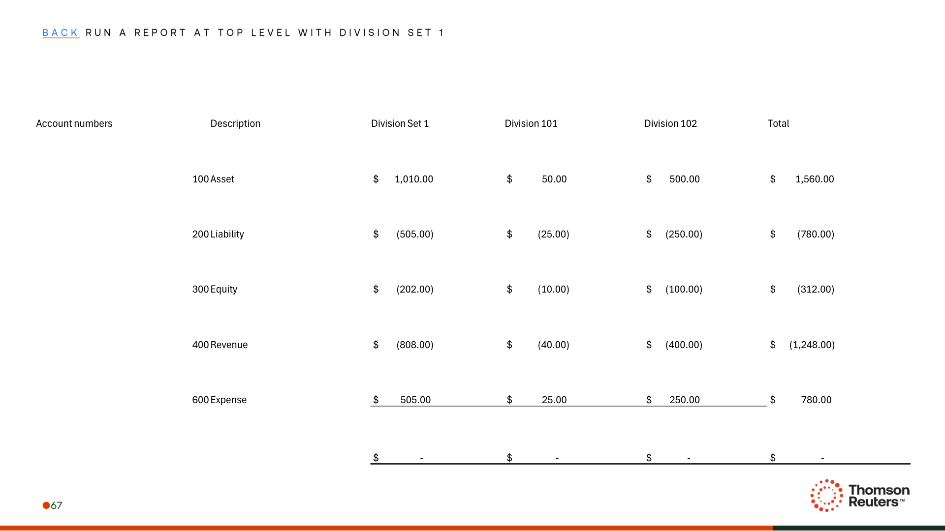
Figure: PDF page 71
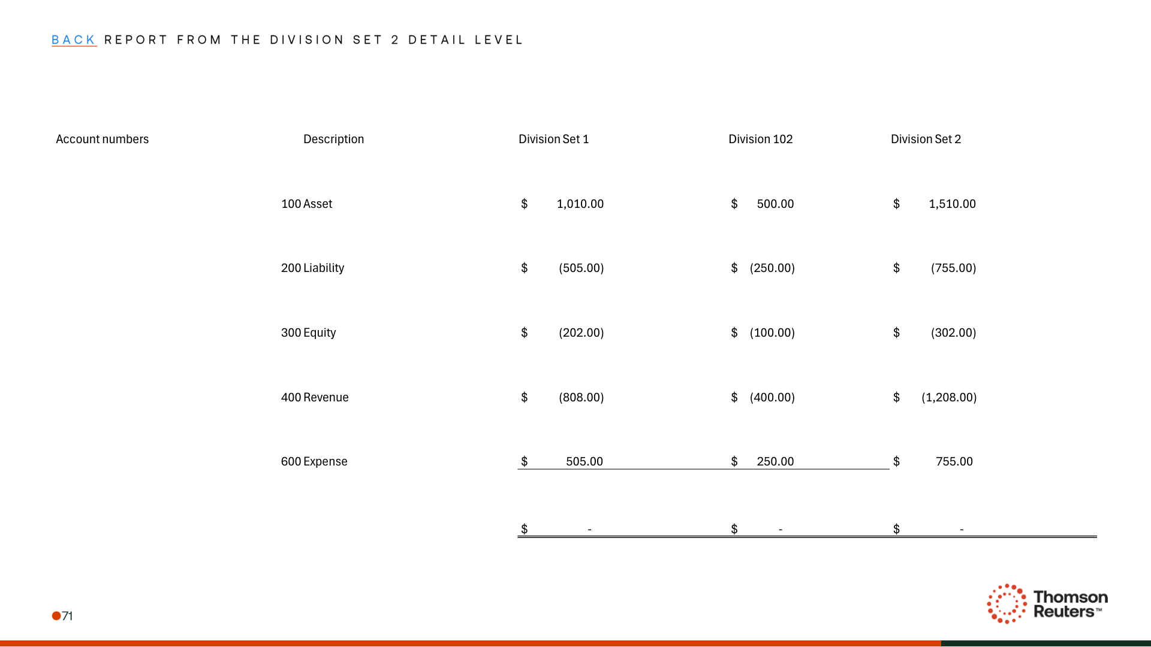
Figure: PDF page 72
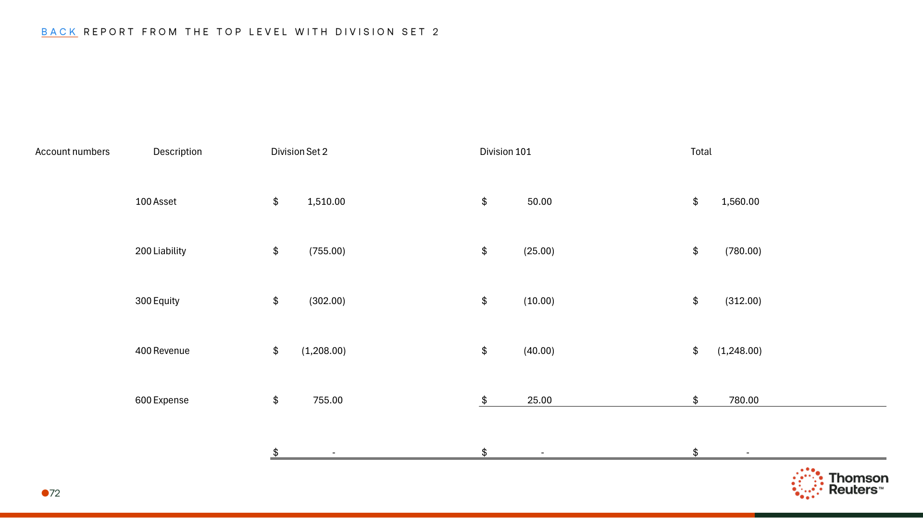

Appendix: Links
ADO Epic Link: https://dev.azure.com/tr-tax/TaxProf/_workitems/edit/4233303

